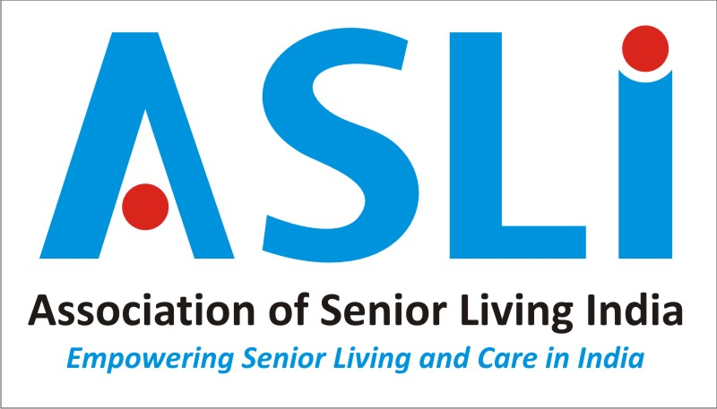

GUIDELINES FOR THE USAGE OF ASLI LOGO AND ITS ETHOS.

- It is essential to carry the logo of our association in all collaterals and stationery of our members to create a distinct identity which has a brand value and value addition to the association and members in many ways.
- It is pertinent to impress upon each and one of us that if the association consolidates and grows, each and every individual member will be benefited, while we speak and act on transparency and credibility, under the banner of the association.
- Let us all collectively ensure that our esteemed association is always kept above all internal dynamics as we work together in taking ASLI to greater heights.
- Only Members who have signed and accepted the code of conduct of ASLI use the LOGO.
- It is mandatory to accept the code of conduct in order to garner benefits of being an ASLI member.
- Members are expected to strictly comply with the design, colour, font and size of the LOGO. It cannot be altered or added or deleted in any way. The size of the LOGO itself can be any size to suit the design and needs of a collateral but the overall alignment cannot be altered.
- The ASLI secretariat or creative agency will provide the logos to our members in different formats such as JPG, PDF,TIFF (Tagged Image File Format),CDR (Coral Draw) and PNG formats.

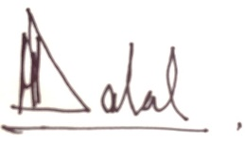
Mansoor Dalal
Founder and Chairman Emeritus.

